CHARLES STURT UNIVERSITY  
MASTERS IN INFORMATION   
TECHNOLOGY

|  |
| --- |
|  |
| REQUIREMENTS REPORT |
| |  |  |  | | --- | --- | --- | | RS MUKESH KUMAR | 10/6/19 | SYSTEM ANALYSIS AND DESIGN | |

Table of Contents

Cloud based Solution 2

Strengths 2

Weaknesses 3

Comparison 3

Why Agile For Cloud based 4

References 5

***CLOUD BASED SOLUTION***

Cloud-based technologies are the most superior innovations influencing supply chain management and warehouse management.

* Cloud-based warehouse management systems offer an extensive array of system functionality, flexibility and complexity and allow users to track and handle high-value inventory with security protocol carefully which is not possible with a SaaS WMS or any other service. The Cloud WMS customizability is sharply suited for medium to large scale businesses and with multi-location distribution centers.
* Cloud-based WMS provides high data security protocols with advanced firewall technology, and Cisco switches for more powerful routing of traffic and protection ( McCooey, E, 2017).
* Cloud-based solution WMS is hosted on a private or segregated server depending on vendor terms. The software vendor can control or customize WMS in the Cloud and can give access privileges to warehouse staff and managers. The ability to make customizations and extra functionality can dramatically increase the ability to adapt to advances in operations and company procedures with limited or no disturbance to current services.
* A cloud-based solution for WMS is adaptable to warehousing needs and can improve efficiency and productivity despite distribution center operation size, volume, or complexity.

***The Strengths and Weaknesses of Cloud Based Solutions***

***Strengths:***

**Data sharing:** The cloud provides a significant to share a information with the vendors, administrators and customers

**Ease of Access:** Cloud-based WMS has access to the system from any location with Internet access through web-based portals.

**Transparency:** In a cloud-based model, the developers can be straightforward and remain up to expectations.

**Automation:** WMS with cloud-based solutions will automatically calculate all the rates and invoice for the client and save time generating reports and invoices, stock movement statements, and conversions.

***Weaknesses:***

**Cyber-Attack Risk:** Some shareholders or clients are unwilling to store their data in third-party management system vendors because there might be a risk of security, and cyber-attacks will exist.

**Upgrades:** Warehouse managers and workers will face pressure due to updates or changes in the cloud.

**Being Competitive:** To be competitive, few warehouses might opt for a change in services and shift to other services and rational functions.As well as demonstrate in-depth understanding of the environment that the solution would be used in

-Based on various aspects and requirements we are opting for cloud-based environment for Jack Greig and Daniel Cox Auto part (WMS).

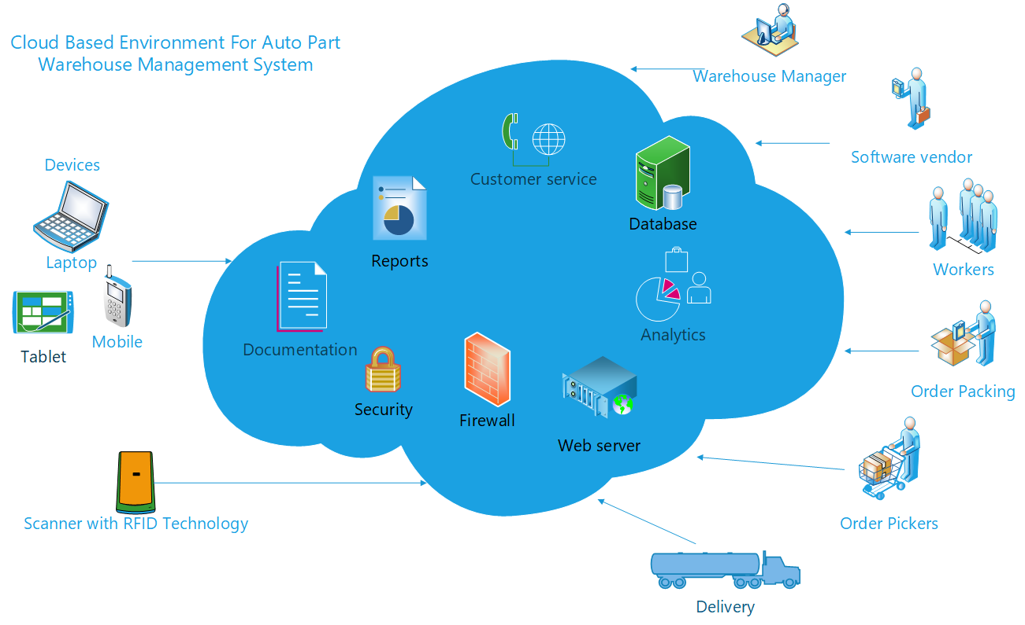

***Comparison of Unified Process (UP) and Scrum for AUTO-PART WMS.***

**Scrum:**

* Scrum is one of the popular agile methods for software development projects. SCRUM has the entire traditional model(waterfall SDLC method) fit into one iteration.
* Scrum team requires three definite roles: product owner, scrum master, and Development team.
* It’s because teams in SCRUM are cross-functional, and the development team comprises designers, testers, and specialists.
* SCRUM methodology uses a project backlog and allows the backlog to modified at the result of each iteration (maximum 4 weeks). Scrum approach is favor to present the whole team responsible and have no roles in the development team.
* Scrum values Running software over extensive documentation and individuals and intercommunications above "processes and tools," which might be a risk in Unified Process.IN scrum or agile use cases or user stories are not mandatory.

**Unified Process methodology**

* Unified Process methodology has significant project milestones and is associated with particular dates.
* Unified Process partitions the lifecycle into four significant stages : Inception, Elaboration,  Construction, Transition.
* This methodology is used often in the domain of web application development and not suitable for cloud.
* This model has pre-defines roles and encourages concurrent workflows across the complete cycle, and specific activities will peak during particular phases. Example: during the elaboration phase, requirements analysis will rise.
* Unified Process has more artifacts and provides guidelines plus templates for plenty of documents.
* In UP, the requirements are used as use cases as it is Use-Case driven and heavy model.

Based on the comparison, a merging of agile and cloud computing is required to provide better infrastructure optimization, automation, and transforming the distribution center into a competitive position.

* Cloud computing and agile is an excellent combination for Jack Greig and Daniel Cox Auto part (WMS).
* The significant insight is the improved excellence uniformity of products, enhanced efficiency of developers, and fewer errors. Continuously increments in scrum with cloud computing will provide better efficiency and value.
* Combining agile development and cloud computing makes software faster with quality.
* Scrum with a cloud-based solution ensures constant interfacing among developers and consumers and also contributes to the best investment with low cost.

**References**

Muhammad Younas, Dayang N.A. Jawawi, Imran Ghani, Terrence Fries, Rafaqut Kazmi (2018)

Agile development in the cloud computing environment: A systematic review, Information and Software Technology, Volume *103*, (Pages 142-158), ISSN 0950-5849, <https://doi.org/10.1016/j.infsof.2018.06.014>.

McCooey, E. (2017). Auto Parts Maker Revs Up Plant With New Technology. Baseline, 19. Retrieved from <http://search.ebscohost.com.ezproxy.csu.edu.au/login.aspx?direct=true&db=bah&AN=124189391&site=ehost-live>